1. COUNT THE OCCURANCE

import java.util.Scanner;

class Occurence{

public static void main(String[] args){

Scanner s=new Scanner(System.in);

int n=s.nextInt();

int arr[]=new int[n];

int e;

for(int i=0;i<n;i++){

e=s.nextInt();

arr[i]=e;

}

boolean f=true;

int t=s.nextInt();

while(f){

f=false;

for(int i=0;i<n;i++){

if(t==arr[i]){

f=true;

t=t*2;

}}

}

System.out.println(t);

}

}

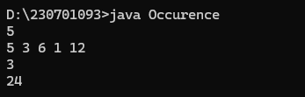

2.INVENATORY MANAGEMENT

import java.util.*

class Stock {

public static void main(String[] args) {

Scanner a = new Scanner(System.in);

int b = a.nextInt();

int[] arr = new int[b];

for (int i = 0; i < b; i++) {

arr[i] = a.nextInt();

}

int minPrice = Integer.MAX_VALUE;

int profit = 0;

for (int i = 0; i < b; i++) {

if (arr[i] < minPrice) {

minPrice = arr[i]; // } else {

int currentProfit = arr[i] - minPrice;

if (currentProfit > profit) {

profit = currentProfit; }

}

}

System.out.println(profit);

}

}

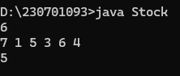

3.SORT THE ARRAY

import java.util.*;

class Sorting{

public static void main(String args[]){

Scanner a= new Scanner(System.in);

int b=a.nextInt();

int arr[]=new int[b];

for(int i=0;i<b;i++){

arr[i]=a.nextInt();

}

Arrays.sort(arr);

for(int i=0;i<b;i++){

System.out.print(arr[i]+" ");

}

}

}

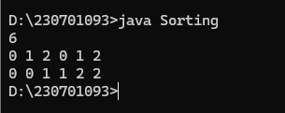

4.MISSING NUMBER

import java.util.*;

class Missing {

public static void main(String args[]) {

Scanner a = new Scanner(System.in);

int b = a.nextInt();

int[] arr = new int[b];

for (int i = 0; i < b-1; i++) {

arr[i] = a.nextInt();

}

Arrays.sort(arr);

for (int i = 0; i < b - 1; i++) {

if (arr[i] + 1 != arr[i + 1]) {

System.out.println(arr[i] + 1);

break;

}

}

a.close();

}

}

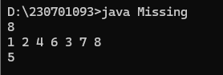\

5.MOVING THE ZEROES

import java.util.Scanner;

class Zeros{

public static void main(String[] args){

Scanner sc=new Scanner(System.in);

int n=sc.nextInt();

int arr[]=new int[n];

int e;

for(int i=0;i<n;i++){

e=sc.nextInt();

arr[i]=e;

}

int t=0;

int s=0;

int temp;

for(int i=0;i<n;i++){

if(arr[i]!=t){

temp=arr[i];

arr[i]=arr[s];

arr[s]=temp;

s++;

} }

for(int i=0;i<n;i++){

System.out.print(arr[i]);

} } }

